**6. SL4J Logging exercises**

**Exercise 1: Logging Error Messages and Warning Levels**

**CODE**

package com.example.logging;

import org.slf4j.Logger;

import org.slf4j.LoggerFactory;

public class LoggingExample {

private static final Logger *logger* = LoggerFactory.*getLogger*(LoggingExample.class);

public static void main(String[] args) {

*logger*.error("This is an error message");

*logger*.warn("This is a warning message");

}

}

**OUTPUT**

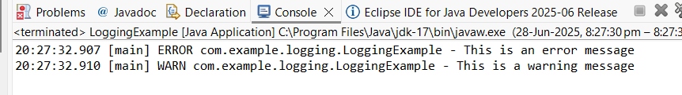

**Exercise 2: Parameterized Logging**

**CODE**

package com.example.logging;

import org.slf4j.Logger;

import org.slf4j.LoggerFactory;

public class ParameterizedLoggingExample {

private static final Logger *logger* = LoggerFactory.*getLogger*(ParameterizedLoggingExample.class);

public static void main(String[] args) {

String username = "kiruthika";

int id = 123;

*logger*.info("User {} logged in with ID {}", username, id);

}

}

**OUTPUT**

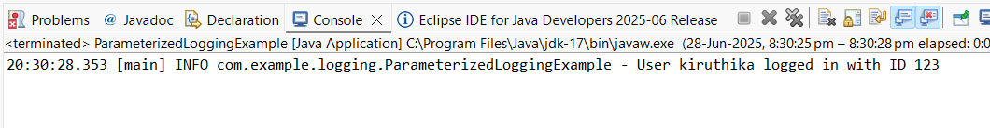

**Exercise 3: Using Different Appenders**

**CODE**

package com.example.logging;

import org.slf4j.Logger;

import org.slf4j.LoggerFactory;

public class AppendersExample {

private static final Logger *logger* = LoggerFactory.*getLogger*(AppendersExample.class);

public static void main(String[] args) {

*logger*.info("This will go to console and file");

*logger*.debug("Debug log example");

*logger*.error("Something went wrong!");

}

}

**OUTPUT**

